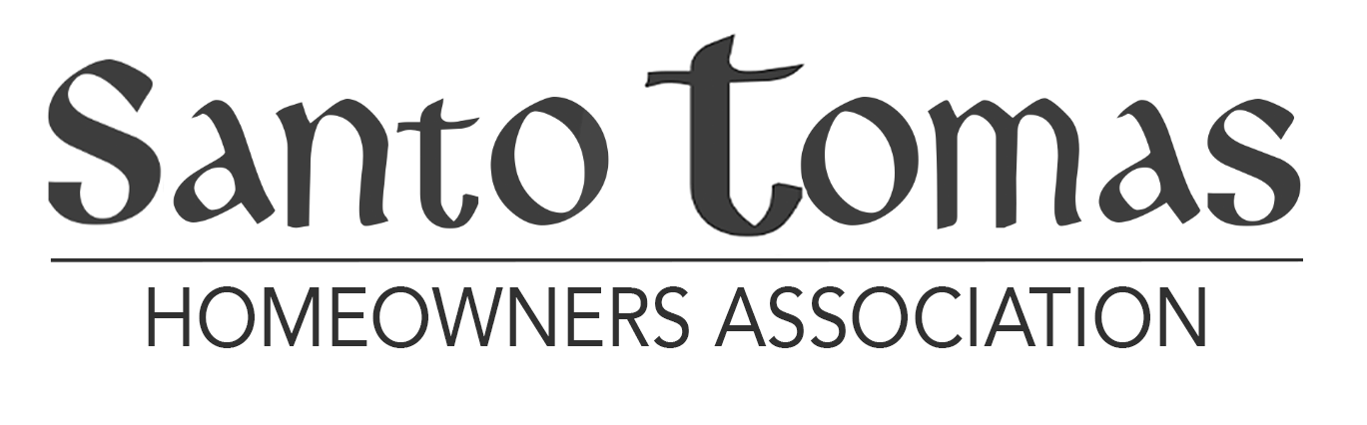

MEETING AGENDA
June 30, 2020 – 5:30-6:30 Executive Session to
6:30-7:30 General Session

VIDEO CONFERENCE
AND
TELECONFERENCE

- Executive Session – Public Session will be recessed and will go into a closed session - ARS 33-1804 – The Board may meet in a closed Executive Session for the purposes of “Legal advice from an attorney for the board or the association. On final resolution of any matter for which the board received legal advice . . . the board may disclose information about that matter in an open meeting . . . .”

- Start of Public Meeting (Approximately 6:15 pm)

- Announcement of Guidelines regarding public input.

- Call to Order and Verification of a quorum.

- Review and Approval of Board meeting minutes for May 18, 2020.

- Financial Reports through May 31, 2020. – Lance Mitchell, Property Manager.

- Architectural Committee Report– Missy Foy, Architectural Committee Chairperson.

OLD BUSINESS

- Canvass of the Election – Motion to accept the results of the election.

- Reconstituted CC&Rs (with changes included) Based on Results of the Election – Motion for: 1) approval of the reconstituted format; and, 2) authorization to record the new CC&Rs as required by the document.

NEW BUSINESS

- Establishment of Santo Tomas Scottsdale Rules – Discussion and motion to begin development to establish rules (beyond Architectural Guidelines) known as the Santo Tomas Scottsdale Rules in accordance with Article V, Section 3 of the CC&Rs.

- Home Owner Forum – Two-minute limitation on each individual who desires to
address the Board.

- Next Board Meeting – October 12, 2020 - 5:30 location and method (i.e. virtual or in person) will be announced based on COVID-19 conditions. Annual Meeting November 16, 2020 6:00 pm.

- Adjournment

